 |  | February 16, 2026

Ivy Tech College School of Information Technology ChatBot Project Plan
 | Prepared for: | Prepared by:
 | Ivy Tech College  School of Information Technology  SDEV 265 - Spring 2026  Steve Carver, Ed. D., MS, MS | Green Team:  Gislaine Azevedo  Zachary Thomas  Kirnechla Davis  Kipp Shinabarger

Contents
Contents 2
Introduction 3
Project Organization 3
Risk Analysis 4
Risk 1: Adaptation to an Existing Platform Code Base 4
Risk 2: External APIs or Dependency Packages in use 5
Risk 3: Team Coordination and Communication Challenges 5
Risk 4: Scope Creep or Changing Requirements from Stakeholders 6
Risk 5: Insufficient Quality Assurance and Testing 6
Hardware and software requirements 7
Hardware Requirements 7
Development 7
Runtime 7
Software Requirements 7
Development Environment 7
Production 7
Additional Tools 7
Work Breakdown 8
Data Flow Diagrams 9
Chatbot Flow (Context Diagram) 9
Chatbot Flow (Main Processes) 10
Project schedule 11
Dependencies Between Activities 11
Monitoring and reporting mechanisms 12
Appendix 12

Introduction
This project plan outlines the development and enhancement of an existing student support chatbot for the School of Information Technology at Ivy Tech Community College. The purpose of this project is to improve the chatbot’s functionality, usability, and reliability in assisting students with common academic and campus-related questions.
This document defines the project structure, roles, risks, technical requirements, development activities, and scheduling plan. Because the project builds upon an existing system, careful planning, coordination, and testing are essential to ensure successful integration and timely completion within the academic term

Project Organization
Position | Member | Description
Organizer | G. Ferraz Azevedo | Oversees timeline, coordinate tasks, ensures milestones are met
Designer | K. Davis | Designs user interface and chatbot interaction flow
Programmer | K. Shinabarger | Implements Chatbot logic by writing the code using JavaScript
Tester | Z. Thomas | Conducts validation tests and debugging.
Figure 1: Project Team
The team follows a structured role distribution to improve accountability and efficiency. While each member has primary responsibilities, collaboration will occur during major milestones such as integration and testing. The Team Lead ensures communication consistency and monitors progress using scheduling tools. The Designer focuses on user experience and interface simplicity. The Developer implements chatbot features and integrates APIs. The Tester validates system functionality and ensures quality assurance standards are met.
Although each member has a defined role, all team members share responsibility for the success of the project. Everyone is encouraged to contribute to coding, designing, reviewing, and testing when needed. This collaborative approach promotes flexibility, strengthens teamwork, and ensures that no single member becomes overwhelmed during the development process.

Risk Analysis
Our team has identified the following five issues that could arise during this project.

Risk 1: Adaptation to an Existing Platform Code Base
This project will be build on a Chatbot developed by previous teams. Our team must quickly learn the existing code base. The existing code may use outdated libraries or coding styles that are unfamiliar to our development team.
Likelihood: Medium
Consequences:
- Potential delays in development
- Introducing bugs or incompatible changes
- Reduced productivity
Response Plan:
- Conduct a thorough walkthrough of the code immediately
- Test the existing code and introduce new functionality incrementally

Risk 2: External API’s or Dependency Packages in use
The existing code base may have existing third-party API’s or Dependencies that have become outdated and unsupported. This could result in additional time to update or replace these third-party packages.
Likelihood: Medium
Consequences:
- Delays in testing due to broken components.
- Additional development time to update or replace the broken dependencies.
- Possible security issues in continued use of outdated dependencies.
Response Plan:
- Identify external dependencies early.
- Monitor third party dependencies throughout the project for potential updates

Risk 3: Team Coordination and Communication Challenges
Team projects can run into scheduling conflicts, leading to delays. Communication styles of each team member can lead to misunderstandings.
Likelihood: High
Consequences:
- Delays in project milestones
- Possible team conflicts and frustration
Response Plan:
- The team will regularly use a discord channel specifically set up for this project.
- Team members will be assigned specific roles and responsibilities.

Risk 4: Scope Creep or Changing Requirements from Stakeholders
Stakeholders may at some point request additional features or request modifications during the project.
Likelihood: Low
Consequences:
- Compromise original core features requested
- Fail to meet deadlines
Response Plan:
- A clear project scope document from the start, requiring stakeholder sign-off.
- A change order process will be in place to evaluate and approve any additions.

Risk 5: Insufficient Quality Assurance and Testing
Likelihood: High
Consequences:
- Dissatisfied users or errors in production environment.
- Reduced confidence in the project.
Response Plan:
- Create dedicated time for testing and user acceptance.
- Involve beta testers for ongoing testing and feedback processes.

Hardware and software requirements

Hardware Requirements

Development
- Any current generation laptop of desktop computer
- RAM requirements will be dependent on the IDE selected
- Well supported internet connection

Runtime
- Any device that can run a modern current web browser
- No other special hardware requirements

Software Requirements

Development Environment
- The existing codebase is in JavaScript, no plan to shift language requirements.
- IDE: Microsoft Visual Code
- Version control: GIT and GitHub

Production
- Web server capable of running the JavaScript codebase

Additional Tools
- Discord - communication with team members
- Google Drive - documentation sharing

Work Breakdown
The project will be divided into the following activities:
- Existing codebase review and dependency audit.
1.1 Conduct detailed review of existing chatbot codebase
1.2 Perform dependency audit and identify outdated libraries
1.3 Document findings and required updates
- Updating any outdated dependencies found in the audit.
2.1 Update outdated dependencies
2.2 Validate system stability after updates
2.3 Perform regression testing
- Expand the existing functionality of the Chatbot to include the ability to direct students to appropriate School of IT catalog web pages.
3.1 Design enhancement for directing students to School of IT catalog pages
3.2 Implement catalog redirection functionality
3.3 Enhance chatbot responses to include suggested catalog links
3.4 Create test cases for expanded functionality
- Testing of the implementation of the expanded functionality.
4.1 Conduct unit testing of new features
4.2 Perform integration testing
4.3 Identify defects and document issues
4.4 Resolve issues and re-test functionality
- Final review and acceptance of the project.
5.1 Conduct final system review
5.2 Obtain stakeholder acceptance
5.3 Prepare project documentation
5.4 Project presentation and system handover
- Project presentation and handover.

Data Flow Diagrams

Chatbot Flow (Context Diagram)
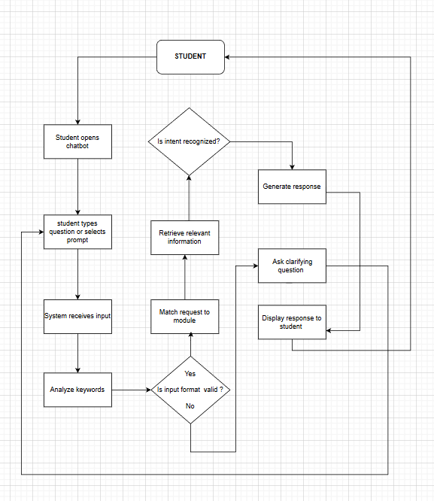
Figure 2: ChatBot Context Diagram
The Data Flow Diagram (DFD) illustrates how user input flows through the chatbot system. The student enters a question through the chatbot interface. The input is processed by the chatbot engine, which evaluates keywords and routes the request to the appropriate module (Financial Aid, Tutoring, Navigation, etc.). The selected module retrieves the relevant response and returns it to the user interface

Chatbot Flow (Main Processes)
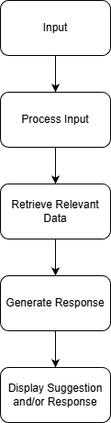
Figure 3: Chatbot Main Process
The main process flow chart illustrates the internal workflow for the Chatbot process once a student submits an input. The input is processed to identify the student's intent.
The system then retrieves the relevant information from its data storage and creates a concise response for the student.
The intent of this workflow is to keep the system modular and easy to maintain or expand.

Project schedule
Week | Activity | Deliverable
1 | Code review and dependency audit | Reviewed codebase and working prototype of prior codebase
2 | Update outdated dependencies and UI | Updated UI working with updated dependencies
3 | School of IT catalog expansion | Update Chatbot to be able to direct students to relevant Catalog website
4 | Continue improving expansion | Finalize improvements to be ready for testing
5 | Testing | Testing results of expansion and existing functionality
6 | Correcting bugs that were found during testing | Stable version
7 | Final review and acceptance | Approval
8 | Final Presentation | Final demo and project handover
Figure 4: Project Schedule

Dependencies Between Activities
- Activity 2 depends on 1
- Activity 3 depends on 1 and 2
- Activity 4 depends on 2 and 3
- Activity 5 depends on 2, 3 and 4
- Activity 6 depends on 5
- Activity 7 depends on 6
- Activity 8 depends on 7

Monitoring and reporting mechanisms
For communication and collaboration, our team decided upon using Discord. Instead of using multiple different services to meet the needs of our development process, we decided to use Discord which is capable of voice, text, and video communication. Along with being a convenient and reliable application for team meetings, it also has a functionality known as “Events”. Using “Events”, our team is able to meet deadlines and schedule in a professional manner.
GitHub is used for version control and code collaboration and Google Drive is used to share documentation. Weekly progress updates are conducted to ensure milestones are achieved. The Team Lead monitors completion status and adjusts timelines if necessary.

Appendix

Activity # | Description | Estimated Time | Dependencies
1.1 | Review existing chatbot codebase | 4hrs | Codebase turnover
1.2 | Perform dependency audit | 3 hrs | 1.1
1.3 | Document audit findings | 1 hr | 1.2
2.1 | Update outdated dependencies | 4 hrs | 1.2
2.2 | Validate system stability | 2 hrs | 2.1
2.3 | Perform regression testing | 2 hrs | 2.2
3.1 | Design catalog expansion feature | 6 hrs | 1.3
3.2 | Implement catalog redirection | 8 hrs | 3.1
3.3 | Enhance chatbot responses with links | 6 hrs | 3.2
3.4 | Develop test cases for expansion | 4 hrs | 3.2
4.1 | Conduct unit testing | 4 hrs | 3.3
4.2 | Perform integration testing | 4 hrs | 4.1
4.3 | Identify and document defects | 4 hrs | 4.2
4.4 | Resolve defects and re-test | 4 hrs | 4.3
5.1 | Conduct final system review | 4 hrs | 4.4
5.2 | Obtain stakeholder acceptance | 4 hrs | 5.1
5.3 | Prepare final documentation | 4 hrs | 5.1
5.4 | Final presentation and handover | 4 hrs | 5.2, 5.3
Figure 5: Project Overview

Total Estimated Effort: 72 Hours

